

**KONGU ENGINEERING COLLEGE**

**PERUNDURAI, ERODE - 638 060**

**(Autonomous)**

**NATIONAL SERVICE SCHEME**



**RALLY ON SINGLE USE PLASTIC**

**AWARNESS**

**[Ref : KEC / NSS / Reports / 2023-2024 / ]**

**Venue: Bhavani**

**Day & Date : 28.02.2024 [Wednesday]**

**Dr. A.MANIMARAN**

**PO / UNIT - I**

**Mr. K.S.NAVANEETHAN**

**PO / UNIT - II**

**Ms. K.SUVALAKSHMI**

**PO / SFU**

**CCO(SA)**

**PRINCIPAL**

Copy submitted to:

1.) NSS Programme coordinator, Anna University, Chennai.

2.) NSS Programme coordinator, Anna University, Regional Campus, Coimbatore.

 **RALLY ON SINGLE USE PLASTIC AWARNESS – 28.02.2024(Wednesday)**

The National Service Scheme and Department of Civil Engineering of Kongu Engineering College,Perundurai organized a rally on “Single Use Plastic Awarness” on 28.02.2024(Wednesday) at 9:00 AM.More than 90 volunteers from NSS participated in the rally.The rally was started at Bhavani.

This rally was organized to make people aware about the single use plastic. And also to encourage the people to use alternatives instead of Single use plastic.

Plastic will make our end drastic !

Let us wipe out plastic before it wipes us out.

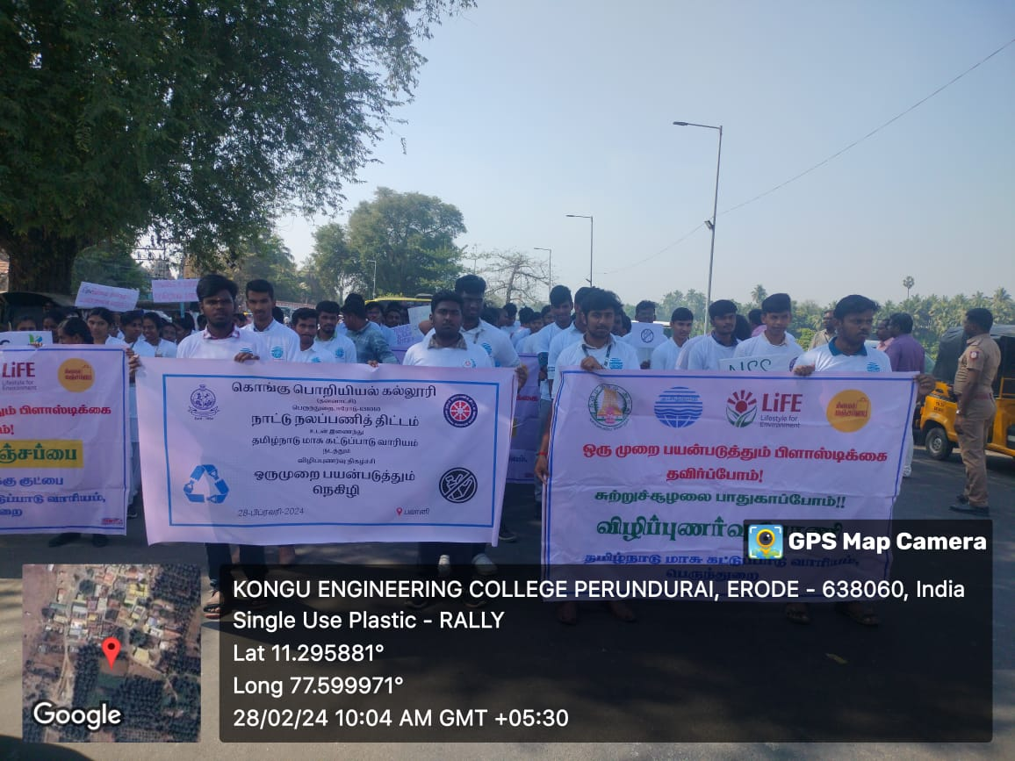 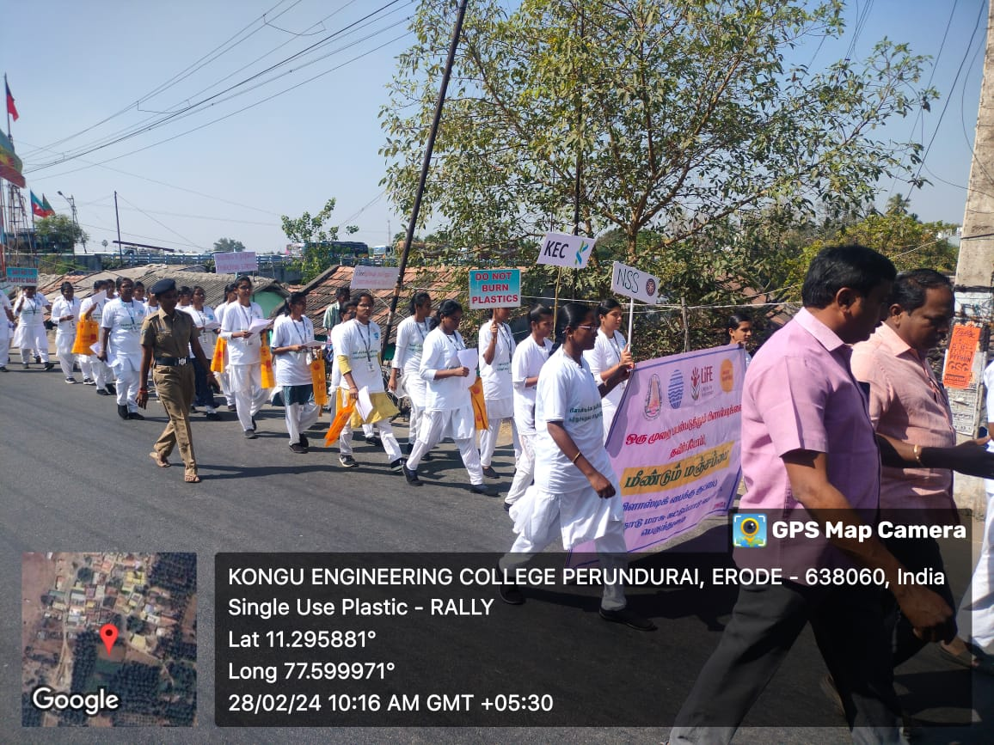

Reducing the use of plastic is the most effective means of avoiding pollution.Carrying reusable bags and water bottles can reduce the usage of plastics .This keeps our environment neat and clean.

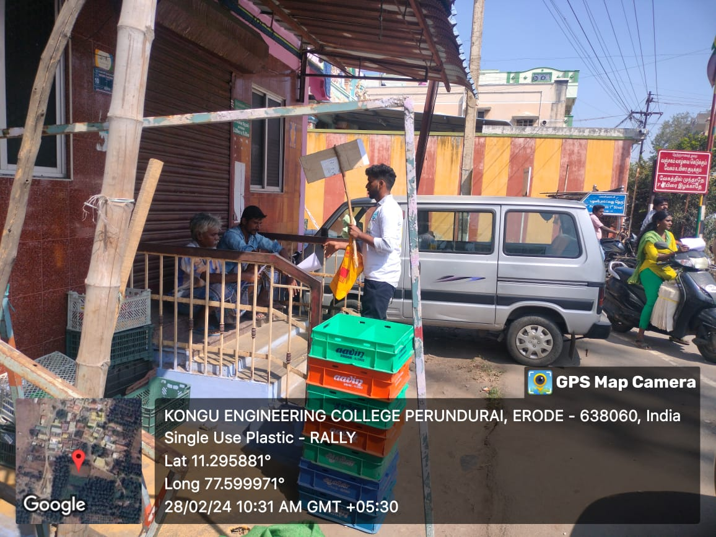 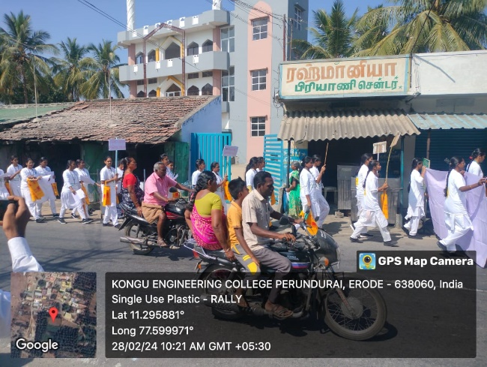

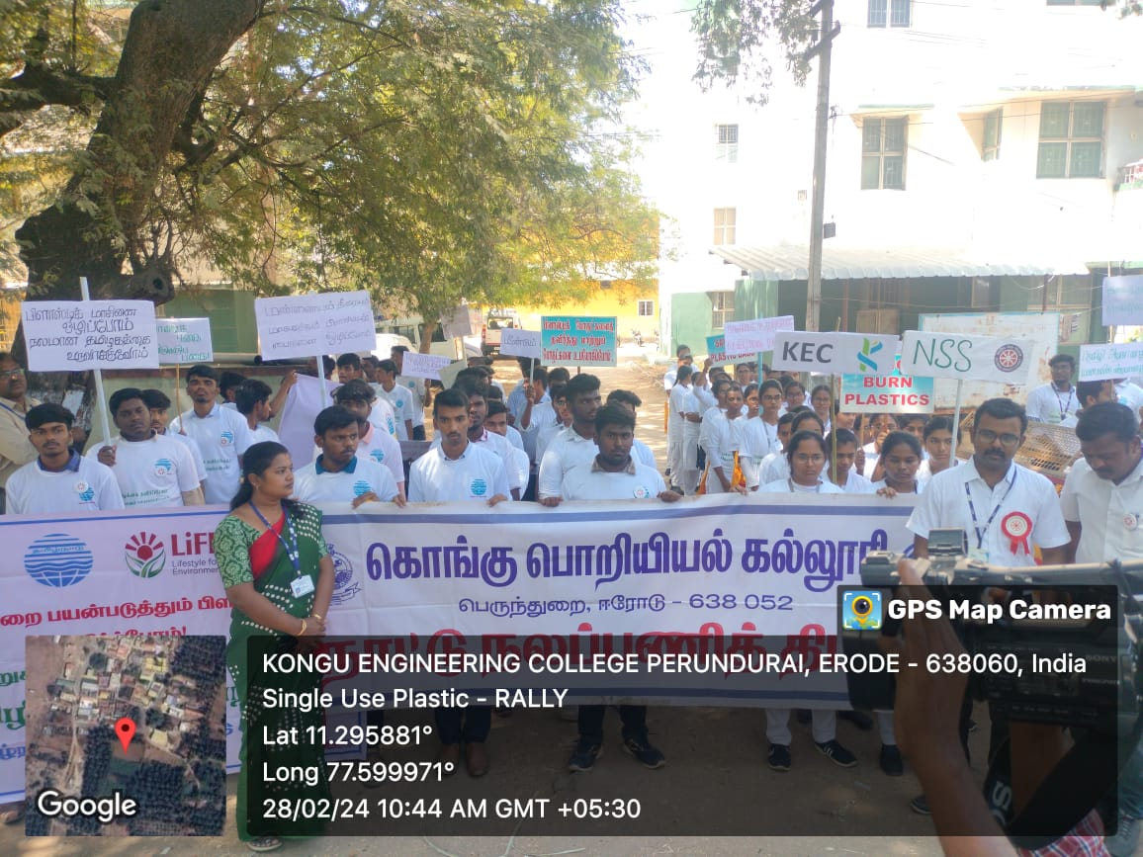

**“REFUSING PLASTIC IS A STEP TOWARDS A HEALTHIER PLANET AND BRIGHT FUTURE“**

**Volunteer’s List :**

|  |  |  |  |  |  |
| --- | --- | --- | --- | --- | --- |
| S.No | Name | Roll No | S.No | Name | Roll No |
| 1 | Aruna T | 22ADR010 |  |  |  |
| 2 | Karthiyayeni B | 22MER036 |  |  |  |
| 3 | Hamini K | 22MER026 |  |  |  |
| 4 | Sudharshana B | 22CSR208 |  |  |  |
| 5 | Hairunisha A | 22ALR024 |  |  |  |
| 6 | Thrisha S | 22CSR026 |  |  |  |
| 7 | Geetha P | 22ALR019 |  |  |  |
| 8 | Shalini Y S | 22CSR186 |  |  |  |
| 9 | Pavithra B | 22CSR143 |  |  |  |
| 10 | Monika N | 22ECR105 |  |  |  |
| 11 | Priyadarshini S | 22CSR154 |  |  |  |
| 12 | Prabhashree S | 22EIR059 |  |  |  |
| 13 | Sindhu K | 22CSR156 |  |  |  |
| 14 | Mythili B | 22CER043 |  |  |  |
| 15 | Kanmani Priya | 22CSR088 |  |  |  |
| 16 | Kaviya S | 22ECR079 |  |  |  |
| 17 | Mathivani R | 22ECL255 |  |  |  |
| 18 | Sandhiya P | 22ECL261 |  |  |  |
| 19 | Sindhu S | 22EIR080 |  |  |  |
| 20 | Subhiksha T | 22EIR095 |  |  |  |
| 21 | Priyadharshini T | 22ALR073 |  |  |  |
| 22 | Nakshathra N | 22ECR116 |  |  |  |
| 23 | Jananiee A P | 22ECR071 |  |  |  |
| 24 | Samvardhani D | 22CSR170 |  |  |  |
| 25 | Sudanthira B | 22CHR067 |  |  |  |
| 26 | Sruthi R | 22CSR205 |  |  |  |
| 27 |  |  |  |  |  |
| 28 |  |  |  |  |  |
| 29 |  |  |  |  |  |
|  |  |  |  |  |  |
|  |  |  |  |  |  |
|  |  |  |  |  |  |
|  |  |  |  |  |  |
|  |  |  |  |  |  |
|  |  |  |  |  |  |
|  |  |  |  |  |  |
|  |  |  |  |  |  |
|  |  |  |  |  |  |
|  |  |  |  |  |  |
|  |  |  |  |  |  |
|  |  |  |  |  |  |
|  |  |  |  |  |  |
|  |  |  |  |  |  |
|  |  |  |  |  |  |
|  |  |  |  |  |  |
|  |  |  |  |  |  |
|  |  |  |  |  |  |
|  |  |  |  |  |  |
|  |  |  |  |  |  |
|  |  |  |  |  |  |
|  |  |  |  |  |  |
|  |  |  |  |  |  |
|  |  |  |  |  |  |
|  |  |  |  |  |  |
|  |  |  |  |  |  |
|  |  |  |  |  |  |
|  |  |  |  |  |  |
|  |  |  |  |  |  |
|  |  |  |  |  |  |